# Routing & Multicast Routing

## Link State Routing

Consider the network shown in Figure 1. The nodes are routers in a network, the edges are links between the routers and the numbers on the edges indicate initial latency measurements (in msec) on that link (the measurements performed by two routers connected to the same link are identical.) The network uses measured latency as its metric.

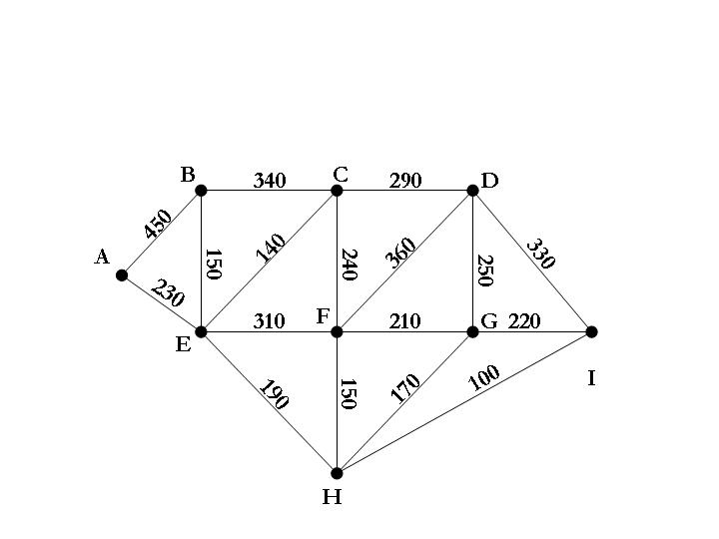

Figure 1

a) Use Dijkstra’s algorithm for finding the shortest path between A and I. A correct answer must include the complete list of routers in the shortest path between A and I, the length of that path and a list that shows the chronological order in which routers were marked permanent by Dijkstra’s algorithm.

b) Show the routing tables of the following three routers A, F, and I. Each entry in these tables has the form [destination, distance, link].

## Distance Vector Routing

|  |  |
| --- | --- |
| Router | Latency |
| E | 390 |
| F | 260 |
| G | 270 |
| I | 380 |

a) Router H in the network of Figure 1 updates its neighbours using distance vectors with the information shown in the table above. Show the progression of the routing information in the network for the times t= 0, 1, 2, … and the influence on the distance of the path from router A to router I.

b) Explain the exchange of routing information in distance vector routing in your own words and contrast it with the approach taken in link state routing.

## Assume that the network below uses multicast routing in dense mode. Node A1, H6 and I4 subscribe to the address 224.0.0.1 and Node A1 sends a datagram to the address. Describe the initial communication between the nodes and the routers at their local network and the transfer of the subscription information and data messages between the routers.



Node H6



Router A

Router B

Router E

Router F

Router C

Router D

Router J

Router H

Router G

Router I



Node A1



Node I4



Typical exam question:

* 1. Assume that 15 Schools of Trinity College, such as “Computer Science and Statistics (CSS)”, “Electronic Engineering (EE)”, “Genetics (G)”, “Chemistry (C)”, etc have individual routers and that these routers are partially connected to one another e.g. the router from CSS may be connected to the router from EE but not to the router from G.
     1. Describe the concept of Distance Vector routing on the example of the computer network in Trinity College. The description should include diagrams that visualise the process that the concept follows to establish routing tables.
     2. Explain the problem of “Count to Infinity” on the network described in I)
     3. Contrast the concept of Distance Vector routing with the establishment of routing tables using a Link State routing approach.